Graphics and Animation Tools
LAB
Experiment – 4 Design your own animation using GIMP

Step 1:

Go to File → open as Layers → Select the image files You want to add in the animation.

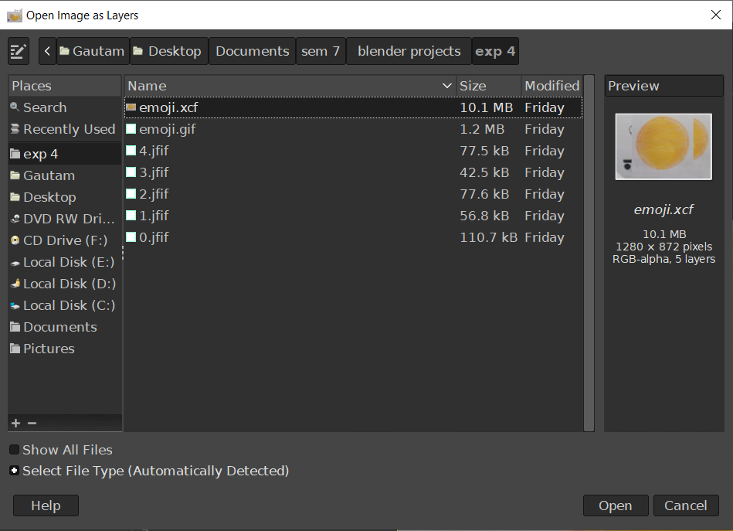

Step 2:

Re-arrange the Layers according to the sequence you want to see them in your animation.

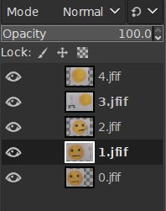

Step 3:

Go to File → Export As → type in your file Name.gif → select File by Extension.

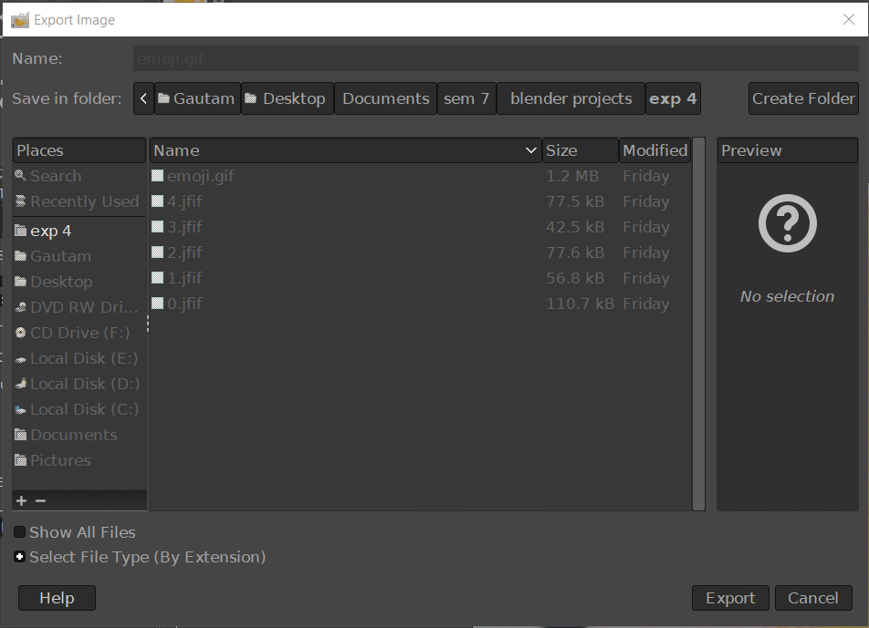

Step 4:

Select As Animation → Select the delay time between frame → And select Delay Between all the layers(from Frame disposal menu).
Tick both the dialogue boxes at the end.
Click Export.
